|  |  |  |  |  |  |  |  |  |  |  |
| --- | --- | --- | --- | --- | --- | --- | --- | --- | --- | --- |
| ■ |  |  |  |  |  |  |  |  |  |  |
|  |  |  |  |  |  |  |  |  |  |  |
|  |  |  |  |  |  |  |  |  |  |  |
|  |  |  |  |  |  |  |  |  |  |  |
|  |  |  |  |  |  |  |  |  |  |  |
|  |  |  |  |  |  |  |  |  |  |  |
|  |  |  |  |  |  |  |  |  |  |  |
|  |  |  |  |  |  |  |  |  |  |  |

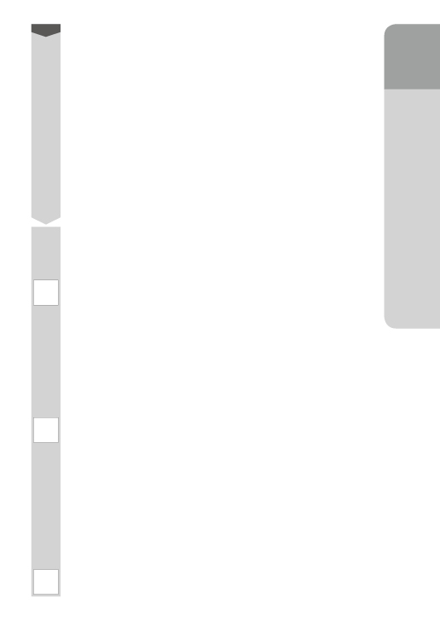

|  |  |  |  |  |  |  |
| --- | --- | --- | --- | --- | --- | --- |
| ■ |  |  |  |  |  |  |
|  |  |  |  |  |  |  |
|  |  |  |  |  |  |  |
|  |  |  |  |  |  |  |
|  |  |  |  |  |  |  |
|  |  |  |  |  |  |  |
|  |  |  |  |  |  |  |

|  |  |  |  |  |
| --- | --- | --- | --- | --- |
| ■ |  |  |  |  |
|  |  |  |  |  |
|  |  |  |  |  |
|  |  |  |  |  |
|  |  |  |  |  |
|  |  |  |  |  |
|  |  |  |  |  |

きょうの　がくしゅうは　どうでしたか。

あてはまる　ところに　○を　つけましょう。

しっかり

かんがえた

あたらしく　きづいた

ことが　あった

これから　たいせつに

したい　ことが　わかった

○